**Experiment No :** 04

**Experiment name :** Write a C program to check whether a string is a palindrome or not .

**Methodology :**

The method of writing this program is, first we will calculate the length of the word we will take the word, then we will reverse the word, and by comparing the reversed word and the original word with each other, we will find out the palindrome word.

**Flow-Chart :**

string1[i] != string1

yes no

char string1[100]; int i, length ; int flag = 0 ;]

Input word

scanf("%s",string1);

**Code :**

Print: not palindorm

Print : palindrom

Flag = 0;

Flag = 1 ;

for(i=0 ; i<length ; i++)

length = strlen(string1);

#include<stdio.h>

#include<string.h>

int main()

{

char string1[100];

int i, length ;

int flag = 0 ;

printf("Etern a word : ");

scanf("%s",string1);

length = strlen(string1);

for(i=0 ; i<length ; i++){

if(string1[i] != string1[length-i-1]){

flag = 1 ;

break;

}

}

if(flag){

printf("%s is not a palindorme",string1);

}

else{

printf("%s -is a palindorme",string1);

}

return 0 ;

}

**Output:**

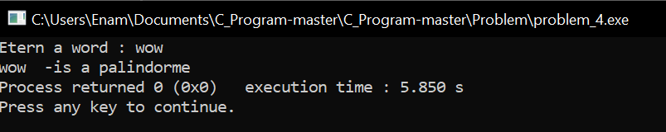

**Result discussion :**

The palindrome method is used to determine whether a word or number looks and reads the same. Is that the same as our input but with numbers and word if read backwards?